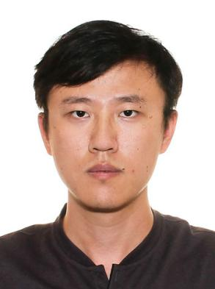
Personal Resume
Birthday：1991/07/21
Height：180cm

Name：YU HAITAO
Nationality：Singaporean
Race: Chinese
Phone：+6598902359
Email：413168358@qq.com
Education
2021/10 - 2024/12 Institute of Microelectronics（Singapore） Senior Research Engineer

Mainly In charge：Etching process development including Metal etching, dielectric etching, Si etching and mask material etching

Projects：
- Tri-layer mask etching process development for immersion lithography
- Si and SiN waveguide process development for high-speed transceivers
- Si Mould process integration flow development and fabrication for Nano-Imprinting
- High aspect ratio TSV(Through-Si-Via) development for layer interconnections
- Nano-TSV etch process development for high speed HBM memory

Working Experience
2010/04 - 2013/03 Manufacturing Engineering , Nanyang Polytechnic
- FYP: Design and development of an Android app which is used for monitoring the combat mission.
2013/08 - 2017/08 Mechanical Engineering(Degree,NTU-MAE)
Core Module：
Electrical Circuits & Electronic Devices、Engineering Graphics、Theory of mechanism、Heat Transfer、Fluid Mechanics、Engineering Materials、Fluid Dynamics、3D printing、C programming language
- FYP: Designed a Virtual Reality application on vision improvement to help doctors to better treat their patients
2022/08 - 2024/05 Computer Control and Automation(Master,NTU-EEE)
Core Module：
Machine Vision, Video Signal Processing, Neural&Fuzzy System, Natural Language Processing, Genetic Algorithms & Machine Learning, Robotics and Intelligent sensors, System Analysis
- Good learning skill, and adapt to constantly changing environment
- Good communication skill and communicate effectively at all levels
- Meet deadlines and coordinate multiple projects with ease
- Good time management, planning/ organizing and presentation skills
Personality

- Fluent in English and Chinese
- Proficient in using PPT, Word, Excel and good reporting skill
Personal Skills

2013/05 - 2017/05 Teknor Apex（Singapore） Lab Technologist
Work Description：
- Raw material and finished goods component detection by using analysis equipment，Includes DSC, Gas Chromatography, FTIR Spectroscopy, TGA
- Injection moulding for physical property test, Includes Tensile test, Flexural test, Izod Impact test
2017/10 - 2021/01 UMC（Singapore） Etch Equipment Engineer

Company Product：L55Flash/RF55-SOI/Logic/eCT40/HV40
Mainly In charge：Lam2300(Kiyo/Kiyo45/Star), Lam SEZ SP4300, Lam DV38

Projects：
- LamDV38 : Edge defect improvement
- LamC3 : OMM alarm ratio reduction
- SEZ SP4300 : dispenser design improvement to prevent water drop
- Auto PM post implementation
- Lam C3 : idle flush liquid replacement for cost down
- Lam Kiyo : Center defect improvement

